# Project Design Phase-II

**Data Flow Diagram & User Stories**

|  |  |
| --- | --- |
| Date | 14 October 2022 |
| Team ID | PNT2022TMID46549 |
| Project Name | Project – Real Time Communication System Powered by AI For Specially Abled. |
| Maximum Marks | 4 Marks |

## Data Flow Diagrams:

A Data Flow Diagram (DFD) is a traditional visual representation of the information flows within a system. A neat and clear DFD can depict the right amount of the system requirement graphically. It shows how data enters and leaves the system, what changes the information, and where data is stored.

## Example: [(Simplified)](https://developer.ibm.com/patterns/visualize-unstructured-text/)

DFD LEVEL 0: Communication flow for specially abled people

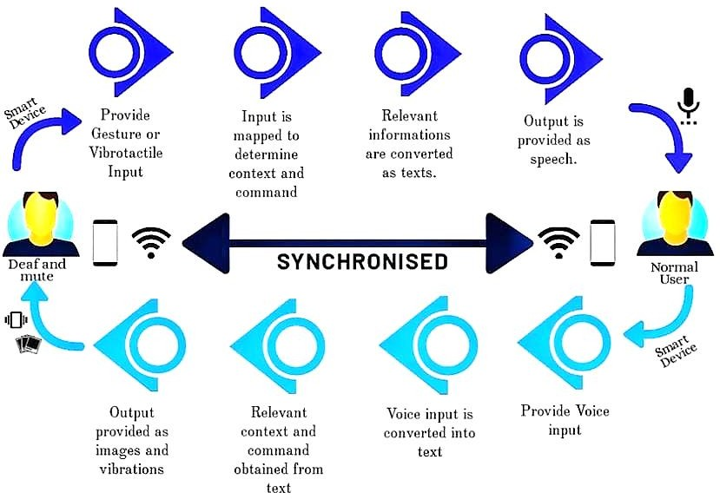



gestures

Predicted label

Video stream

Open source Histogram Extract

computer vision hand

frames

Transform

to frames

Convolutional

Neural Network

Anticipate

the actions

Camera lens

Customer

**User Stories**

Use the below template to list all the user stories for the product.

|  |  |  |  |  |  |  |
| --- | --- | --- | --- | --- | --- | --- |
| **User Type** | **Functional**  **Requirement (Epic)** | **User Story Number** | **User Story / Task** | **Acceptance criteria** | **Priority** | **Release** |
| Customer (Mobile user) | Registration | USN-1 | As customer, I could able to register for the app by entering my E-mail and proper password. | I could able to access my registered account. | High | Sprint 1 |
|  |  | USN-2 | As a user, I'll get the acknowledgement verification email once after my registration has been done for the app | I can get verification email and click ok to confirm it.. | High | Sprint 1 |
|  |  | USN-3 | As a customer, I could able to register for application via their official websites and social media. | I could able to register and access my account by using their website & social media. | Medim | Sprint 2 |
|  |  | USN-4 | As a customer, I could able to register for application through Gmail | via some third parties link | Low | Sprint 2 |
|  | Login | USN-5 | As a customer, I could able to login into application by entering already registered email and password | I can type manually and also can used saved login credentials | High | Sprint 1 |
|  | Dashboard | USN-6 | As a customer,I can get all services and help in dashboard | I can access my dashboard and change profile | Medium | Sprint 2 |
| Customer (Web user) | Registration | USN-7 | As a customer, I could able to login through registered phone number by using otp instead of Gmail | I could able to register & login via phone number to access my account | High | Sprint 2 |
| Customer Care Executive | Service | USN-8 | Can avail the service by calling customer care or reaching through E-mail. | Can avail the service by calling customer care or reaching through E-mail. | Medium | Sprint 1 |
| Administrator |  | USN-9 | Respective person in the company should take care all of this. | All the requirements are there. | High | Sprint 2 |
|  | Sign up | USN-10 | Customer have to sign-up to use these things and all | Have to enter valid credentials. | High | Sprint 2 |

|  |  |  |  |  |  |  |
| --- | --- | --- | --- | --- | --- | --- |
| **User Type** | **Functional Requirement (Epic)** | **User Story Number** | **User Story / Task** | **Acceptance criteria** | **Priority** | **Release** |
|  | Wish list | USN-11 | Customer's desired choices to avail these services. | As a customer can review and choose their services as he want/preferred. | Medium | Sprint 1 |
|  | Enrollment | USN-12 | Now, customer can avail all services once he/she enrolled. | As a customer, it's quite enchanting | Medium | Sprint 2 |